TEAM4OIES

Input Forms and Output Reports

Version 4.0

Signature Block

COSC 4351 | Name Signature | Date
SE Team Leader | Javier Rivera
SE SQA | Linh Tong
SE SQA | Paul Miller
SE Team Leader
SE SQA
SE SQA
SE Team Leader
SE SQA
SE SQA
Actor: Any User
- Search Testimonials: A search bar is displayed for typing in keywords and when user clicks the search button, website will generate the output report. The testimonials are output in the search results box in table format.

Input Form:

Search Testimonials

Awesome
SEARCH

Output Report:
Any user is able to view the testimonials on TEAM4OIES website. The testimonials will output in the search results box in table format.

Testimony | Date
“I love this website!!!” | 2/2/2012
“I love the simple upload function on this site!” | 3/5/2014

Actor: Auditor, Surgeon, CFD Scientist, Computational Scientist
- Enter Testimony: Users can leave feedback about the website here and TEAM4OIES website will grab important information like Actor’s name and date. This information will be stored in TEAM4OIES database to be used in Testimonial output forum.

Input Form:

Feedback and Inquiries

Comments (max 500 characters)

SUBMIT

Actor: Visitor
- Surgeon Registration: Multiple fields are displayed for the visitor to input information. Once the information has been input, a completion message is displayed (with possible email confirmation message). Email also will be used as username. Occupation field is dropdown menu.

Input Form:

Create a New Account

User Name:
Occupation:
Surgeon

Institutional Email:
CFD Scientist
Computational Scientist

Password:

Confirm Password:

Institution ID:

Register

Output Report:

Registration Successful!

Please verify your email xyz@domainname.com.

LOGIN

Actor: Surgeon
- Surgeon Anonymize: Surgeon can browse their local computer to find patient data. Once the data has been selected, the surgeon can click on the button to anonymize the patient data. A message is displayed when the data has been anonymized successfully.

Input Form:

Anonymize EVAR Data

Select Patient Folder on Local PC

Browse

Anonymize Patient Data

Output Report:
RETURN
Anonymize successful!
Anonymize EVAR Data
Actor: Surgeon

- Surgeon Upload File: Surgeons will be able to upload patient’s anonymized EVAR data to server by selecting the zip file on local computer and entering the requited data in form. Brand and Entry Point data are dropdown menu.

Input Form:

Upload Patient File

Browse…
Select File:
C:/users/Desktop/filename.zip

Date of Surgery:
MM/DD/YYYY

Endograft Characteristics

Brand:
Select
Diameter
Length
Endograft Body:
Unilateral Leg:

Contralateral Leg:

Entry Point:

UPLOAD ANONYMIZED PATIENT

Output Report:

RETURN
Upload File
File upload successful!

Actor: Surgeon

- Surgeon Data Analysis: Surgeon is able to store data analysis after downloading and studying EVAR data on patients.

Input Form:

Data Analysis

Patient Number:
Sex:

Patient DOB:
Date of Surgery:

Patient Age:
Graft Manufacturer:

Select CT Series
Select CT Scans
Delay

Total # of slides
Thickness
Pixel Size

Illiac Bif
ROI End

ROI Begin

ROI length (cm)
Comments (500 characters)

Total Slices in ROI

Save Analysis

Output Report:

RETURN
Data Analysis

Data save successful!

Actor: Surgeon, Computational Scientist

- Download EVAR CT: Surgeons and computational scientists is able to download data for analysis by entering patient ID.

Input Form:

Download Patient File

Enter Patient ID:

DOWNLOAD

Screenshots added by VH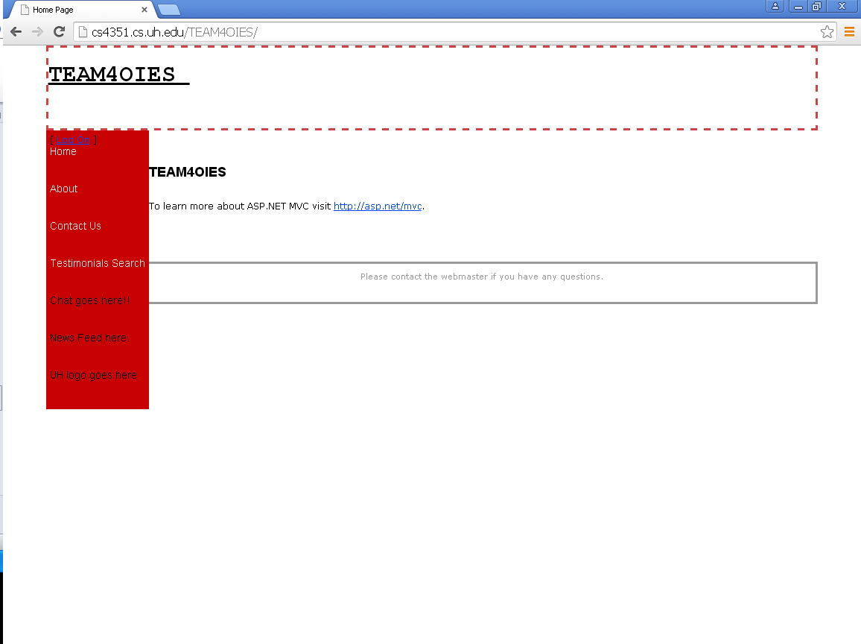 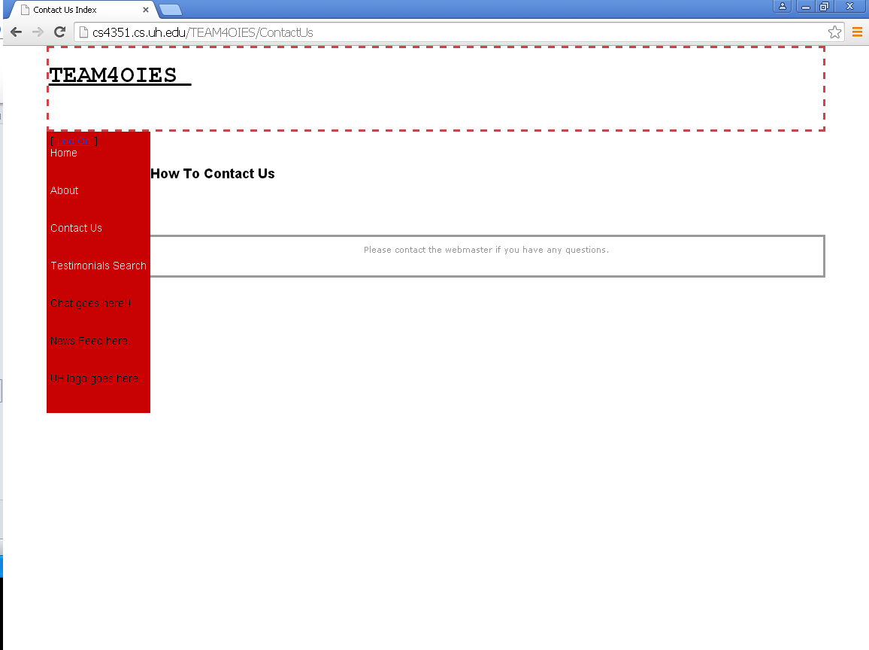

Document Control
CHANGE HISTORY
Table 1: TLs entries (assigned work and due dates) before releasing to the team (all SQAs)
Revision | Name | Due Date | Description
1.A | TM Daniel Gonzalez | 02/08/2015 | Add your work to Document
1.B | TM Steven Pate | 02/08/2015 | Add your work to Document
1.C | Jainesh Mehta | 02//08/2015 | Add your work to Document
1.X | Paul Miller | 02/09/2015 | Review Document
1.Y | Linh Tong | 02/09/2015 | Review Document

Table 2: Entries when work completed (SVN Commit Comment matches Description)
Revision | Name | Completed Date | Description
1.A | TM Daniel Gonzalez | 02/10/2015 | Created the output report
1.B | TM Steven Pate | 02/09/2015 | I put together a design for the input report
1.C | DBA Jainesh Mehta | 02/10/2015 | Changed text for output report.
1.X | SQA Paul Miller | 02/10/2015 | I reviewed Document
1.Y | SQA Linh Tong | 02/10/2015 | I reviewed Document

Table 3: TL entry for RED DELIVERABLES (SVN Commit Comment matches Description)
Revision | Name | Due Date | Description
2.0 | TL Javier Rivera | 02/11/2015 | I changed Version to 2.0

Change History
Table 1: TLs entries (assigned work and due dates) before releasing to the team (all SQAs)
Revision | Name | Due Date | Description
2.A | TM Daniel Gonzalez | 03/06/2015 | Add your work to Document
2.B | TM Steven Pate | 03/06/2015 | Added more input/output forms
2.C | DBA Jainesh Mehta | 03/06/2015 | Fixed some text and forum layout.
2.X | SQA Paul Miller | 03/07/2015 | Review Document
2.Y | SQA Linh Tong | 03/08/2015 | Review Document

Table 2: Entries when work completed (SVN Commit Comment matches Description)
Revision | Name | Completed Date | Description
1.A | TM Daniel Gonzalez | 03/08/2015 | Completed Task
1.B | TM Steven Pate | 03/08/2015 | Added additional input and output reports and updated previous input output report
2.C | DBA Jainesh Mehta | 03/08/2015 | Fixed text for forums.
2.X | SQA Paul Miller | 03/08/2015 | I reviewed Document
2.Y | SQA Linh Tong | 03/08/2015 | I reviewed Document

Table 3: TL entry for PURPLE DELIVERABLES (SVN Commit Comment matches Description)
Revision | Name | Due Date | Description
3.0 | TL Javier Rivera | 03/09/2015 | I changed Version to 3.0

Change History
Table 1: TLs entries (assigned work and due dates) before releasing to the team (all SQAs)
Revision | Name | Due Date | Description
3.A | TM Steven Pate | 04/12/2015 | Remove unwanted Input and Output reports. Fix models to match our website
3.B | TM Daniel Gonzalez | 04/12/2015 | Completed Task
3.X | SQA Paul Miller | 04/14/2015 | Review Document
3.Y | SQA Linh Tong | 04/14/2015 | Review Document

Table 2: Entries when work completed (SVN Commit Comment matches Description)
Revision | Name | Completed Date | Description
3.B | TM Steven Pate | 04/12/2015 | Completed task
3.C | TM Daniel Gonzalez | 04/12/2015 | Completed task
3.X | SQA Paul Miller | 04/14/2015 | I reviewed Document
3.Y | SQA Linh Tong | 04/14/2015 | I reviewed Document

Table 3: TL entry for BLUE DELIVERABLES (SVN Commit Comment matches Description)
Revision | Name | Due Date | Description
4.0 | TL Javier Rivera | 04/15/2015 | I changed Version to 4.0

Document Storage
This file is stored in SVN at https://svn.cs.uh.edu/svn/cosc4351/team4/TEAM PROJECT DELIVERABLES/Input Forms and Output Reports.doc.

